Copyright

by

Anh Luong

2014

HIDDEN TEXT: Optional—If you do not include a copyright page, delete entire page and the following page break.

HIDDEN TEXT: NOTE: this page in hard copy with all original signatures must be submitted with the dissertation to the Graduate School; this is required whether the document is in electronic format or on paper. Whereas, the page included in the electronic document will be unsigned unless it is scanned in.

The Report Committee for Anh Luong

Certifies that this is the approved version of the following report:

ClosetStylist: An Android app to manage closet and programmatically pick out the outfit

**APPROVED BY**

**SUPERVISING COMMITTEE:**

|  |
| --- |
| **Supervisor:** |
| Adnan Aziz |
| Christine Julien |

HIDDEN TEXT: The top line is for the Supervisor’s signature. There should be as many lines as there are members on the committee. Lines must be solid, not dotted. To delete signature lines, select the line you want to delete, go to the Table menu, select Table Properties, click on the Table tab, and click on the Borders and Shading button, then remove the bottom border of the table. Use the professor's name without titles or degrees

ClosetStylist: An Android app to manage closet and programmatically pick out the outfit

by

Anh Luong, B.S.E.E.

HIDDEN TEXT: Given first name, and previous academic degrees (B.A. or higher) B.A., B.S., etc. Your official name is the name which appears on your UT transcript.

Report

Presented to the Faculty of the Graduate School of

The University of Texas at Austin

in Partial Fulfillment

of the Requirements

for the Degree of

Master of Science in Engineering

HIDDEN TEXT: The degree sought must be worded in the form given in the Graduate Catalog, such as Doctor of Philosophy, Doctor of Musical Arts, Doctor of Education.

The University of Texas at Austin

May 2014

Dedication

To my parents and my wife.

Acknowledgements

First of all, I would like to thank all of my professors and teachers who have given me invaluable knowledge I have today. Especially, I would like to express my gratitude to my supervisor, Professor Adnan Aziz, who has offered guidance on the iTrak project, and to my reader Thangavel Subbu. I would also like to thank the friends I traveled with, who gave me the inspiration for iTrak. Most importantly, I want to thank my parents and my sister for all the hard work and sacrifices they have made to unconditionally support me with my studies.

ClosetStylist: An Android app to manage closet and programmatically pickout the outfit

Anh Luong, M.S.E.

The University of Texas at Austin, 2013

Supervisor: Adnan Aziz

iTrak is a combined mobile and web application that takes advantage of the GPS to allow travelers to share their experience while travelling. The application gathers GPS data and broadcasts it via a web interface or social networks such as Facebook to update user’s status during a trip. iTrak is also equipped with other features such as writing notes or recording video journals to offer a rich experience and provide an interactive diary, along with a real-time tracking ability, for travelers.

## 

## Chapter 1 Introduction

### Motivation

Travelers, especially backpackers, often stay quiet among the users of mobile Internet services and social networks. Instead, teenagers or college students are often mentioned as users of these services. However, different researches and surveys have proved that travelers are among the early users of mobile Internet services. For example, surveys conducted by Tjøstheim, Lous, Nordlund, and Fuglerud between 2000 and 2003 showed that travelers with e-commerce experience would be among the early adopters of mobile Internet services [TLNF2003]. The 2002 survey showed that among the travelers who participated in their surveys, 100% (458) of them were Internet users and 73% (334) of them had e-commerce experience, compared to 58% (3094) and 29% (1544) respectively in a national survey with random participants in 2001. These results showed that travelers are above the national average of Internet users and made them potentially early adopters of mobile Internet services.

Further studies conducted by Jeff Axup and Stephen Viller indicated that in the backpacker culture, there was a high demand for mobile devices and services to help travelers share their experience or socialize and connect with each other [AV]. With the recent blooming of the mobile technology and social networks, it is feasible to fulfill such demand. Nowadays, a user can use a single smart phone to do different things while travelling, such as note taking or updating their trip status on social networks. However, the user likely has to use separate apps for different tasks. As more applications and social networks are being created, it would be tiring to maintain all the apps and update status in every network. It would be more convenient if there was a single application that allowed travelers to achieve all those tasks.

### Vision

iTrak addresses the above problem by providing a centralized service where travelers can use a single mobile app to record their exciting travelling moments and stay connected with people across all networks. The target audiences of iTrak are backpackers, or travelers who possess the backpacker culture. The application itself will focus on the core functionality of tracking and creating travel notes, while at the same time providing a seamless portal for users to connect with people in their existing social networks. It will integrate with the GPS to provide live status update and trip tracking, which a user can share with friends and family. iTrak will also focus on providing functionalities that are often needed by travelers such as taking photos or recording voice and video journals.

iTrak will consist of a mobile app, a web app and a cloud service. The mobile app is mainly for obtaining GPS data, creating notes and saving them to an online repository. The web app will act as a personal blogging page that presents the travel experience collected from the mobile app. This interface will provide a user with a private blogging space to share travel experience, while still staying connected with friends and family in the user’s social networks. To aid the interaction between the mobile app and web app, a collection of cloud services will be developed to handle data transferring, GPS data processing, and media managing.

### Scope

This report will focus on three main aspects: the design of iTrak, the iTrak prototype, and the testing methodologies.

First, the report will visit the user interface and architecture designs of iTrak. It will go through the technologies used in iTrak to acquire the GPS data, how to store the data and how the data will be used for the live tracking feature. The report will also explain how iTrak will be integrated with existing social networks.

Then the report will discuss the iTrak prototype, which has been developed in parallel with the writing of this report. While the user interface and architecture designs cover a larger and more complete vision of iTrak, the prototype focuses on demonstrating only core functionalities of iTrak, including acquiring and using GPS data, how the data can associate with travel diaries and how the Facebook social network will take part in the application as a whole.

Along with the iTrak architecture and the prototype, this report will visit several testing methodologies and metrics that can be used to ensure the data integrity and the performance of the application.

### Report organization

In the next section, I discuss provide the user stories, user interface, and mockups to present the functionalities and the workflow of the ClosetStylist. Section 3 describes the technology stack applied to this app and the architecture of this app. Section 4 provide the result, testing methodologies used for quality control of the app. Section 5 concludes the paper, provides related and future work.

## Chapter 2 User Interface Design

### 2.1 Overview

In this section, we describe several user stories to demonstrate what ClosetStylist app can be used for and some high level use cases that serve as user guide of the app. These are just some examples and does not dictate or limit users on how to user the app.

A usage flow will also be presented by a set of mockups to visualize the user interface.

### 2.2 User Stories

The below stories highlights some aspects that ClosetStylist has achieved:

* Users can easily go through and look at every item in their own clothing inventory.
* Users can find out how many dirty items are there to schedule to do laundry.
* Users can go through their worn history and look for what apparels they wore on any date in the past.
* Users can choose any outfits that the app has recommended based on the weather at the current location.

### 2.3 Use Cases

The use cases presented in this report followed the Agile modeling approach [Amb] to effectively model the high level structure and the workflow of the application. These use cases focus on describing how social networks should interact with iTrak activities. Each use case consists of an activity diagram, which is based on the Grid Flow Chart model developed by Les Matthies [Bry], and a textual description that describes the use case steps in more details. This approach worked well with the iTrak prototype because it allowed the general model of the application to be rapidly constructed and visually presented, while at the same time offered enough information about the main activities and features that would need to be developed.

In all of the below cases, there are always two actors – a user and the ClosetStylist Android app.

#### 2.3.1 Register



Figure 2.1: Register diagram

The precondition: ClosetStylist has already been installed on the device under test.

The purpose: show how the user can register an account to use the app the very first time and how to populate all the required fields.

The steps: the app has its own simple authenticating method to validate, independent of any social networks, so that the users can still use the app if they choose to not use any social network feature. When this is the very first time the app is launched, users click on the “Don’t have account – register here” and fill in the required fields, one of which is the postal code. The interesting point about this field is this is the default location that the app will use if it fails to find the current location later. If users don’t know their current zipcode, they can click on “Get Location” and the app will find the zip code based on the current location. Once the users have filled in all the required fields, they can click on the “Register” button to log in to the app. The user’s information is also persisted to the app database so that user can login the next time.

#### 2.3.2 Login



Figure 2.2: Login diagram

The precondition: Users have already registered.

The purpose: Users will need to enter username and password to login after the their registration

The steps: launch the app and enter their credentials. The app will navigate to the main screen where users can find information about the current location, date, weather, and they can to proceed to any of the four main pages: Outfit of the day, My Closet, My Laundry Bag, My Outfit History.

#### 2.3.3 Add new item



Figure 2.3: Add new item diagram

The precondition: users are logged in.

The purpose: Users need to populate their closets with their clothes so that the app can programmatically pick out the outfit for any day.

The steps: From the main screen, users click on “My Closet”. In the bottom of the My Closet page, there is “ADD ITEM” button. After filling in the required fields, users can take picture of the clothes by clicking on the camera icon. Once saved, users can crop the newly taken picture to get rid of the unnecessary parts. Users can choose either Reset all the fields or Save it. Clicking on “Save” button will save the detail of this item while clicking on “Reset” button will reset all the fields to the default values.

#### 2.3.4 View or edit an item



Figure 2.4: View or edit item diagram

The precondition: the item has been added to the closet.

The purpose: View the detail of an item and update the information if needed.

The steps: From the main screen, users click on “My Closet”. The wardrobe is categorized as “Outer”, “Top”, and “Bottom”. Users choose the tab that the wardrobe belongs to and click on the items they want to see. They can choose to change any of the fields, and can even mark an item is dirty to be sent to laundry.

#### 2.3.5 Pick an outfit



Figure 2.5: Pick an outfit diagram

The precondition: “My Closet” has been populated with some items in both Top and Bottom.

The purpose: The app programmatically suggests a list of outfits that best fit the user based on the weather and the occasion.

The steps: From the main screen, users click on “Outfit of the Day”. The app will display a list of suggested outfits based on the current weather and the Occasion set to “Casual”. There are 5 options for Occasion – “Formal”, “Semi\_Formal”, “Casual”, “Day\_Out”, “Night\_Out” and users can choose the appropriate Occasion. There are arrows to switch to another Top or Bottom. There are double-arrows to let the user traverse through the list of suggested outfits. Once the users decide to choose a particular outfit, they can click on the “WEAR” button at the bottom and they will be navigated to the “My Outfit History” page.

#### 2.3.6 View outfit history



Figure 2.6: View outfit history diagram

The precondition: users have already chosen to wear some outfits.

The purpose: Display the outfits that users have already worn on any particular day.

The steps: From the main screen, users click on “My Outfit History”. The page displays the outfits that users have worn on a particular day, starting with today. If users have worn several outfits on the same day, all of them will be listed in chronological order, starting with the one worn earliest in the day. User can click on any of them and they will be navigated to the “Outfit Preview” to see a more detail picture of the outfit.

#### 2.3.7 Laundry bag



Figure 2.7: Laundry bag diagram

The precondition: Users have already chosen to wear some outfits.

The purpose: Display the dirty items so that the users can schedule to wash them.

The steps: From the main screen, users click on “My Laundry Bag”. The page will display all the dirty items as a list. Users can click on any of them to view more detail.

### 2.4 Mockups

A set of mockups was designed to provide a vision of how iTrak would look like on the mobile interface and web interface. All mockups were created using the Balsamiq [Bal] software, which offers a powerful and user friendly interface to conveniently create mockups. A storyboard of these mockups were also put together to describe the workflow of the iTrak application. This storyboard is presented in Figure 2.5. More details of each mockup in the storyboard are available in the following sections.

#### 2.4.1 Mobile App Mockups

|  |  |
| --- | --- |
| C:\Users\code_warrior\Desktop\mockup.png |  |

Figure 2.6: User login and registration mockups.

In Figure 2.6, two mockups for the user login and registration pages are presented. The Login page will be displayed if the mobile app does not find a login session saved previously when user first launches iTrak. Otherwise, iTrak will display the main page as seen in Figure 2.7.

In Figure 2.7, Mockup 2.7a shows the main page of iTrak mobile app. The status bar at the top of page shows whether a trip is currently active or not. The main page also contains icons for the main functionalities which are described with more details in Table 2.1.

Mockup 2.7b shows the live map view when user presses the Live map icon from the main page. This live view page allows user to review the itinerary made within the day. When there is not an active trip, the live view will simply show the last location recorded by iTrak.

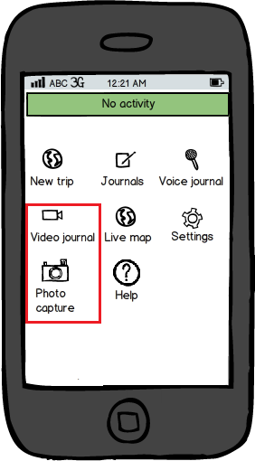

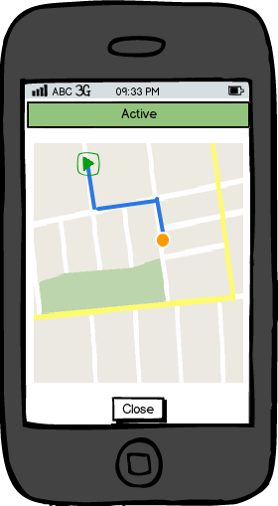

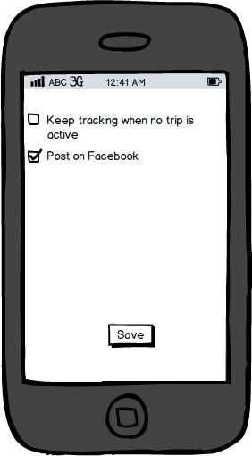

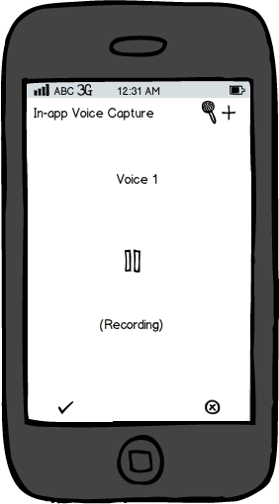

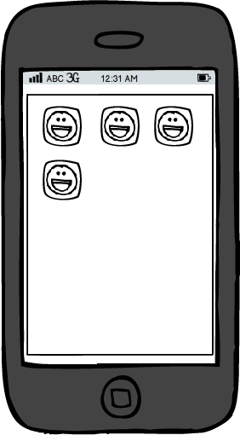

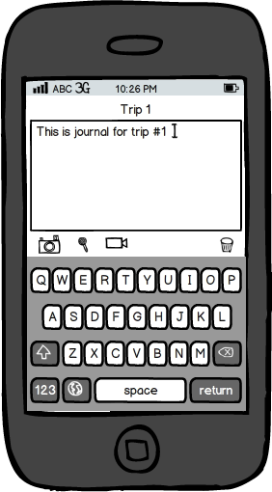

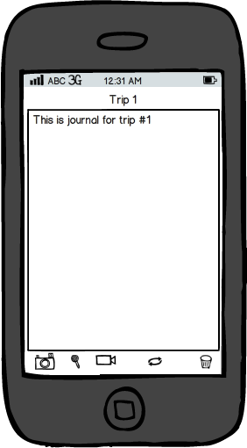

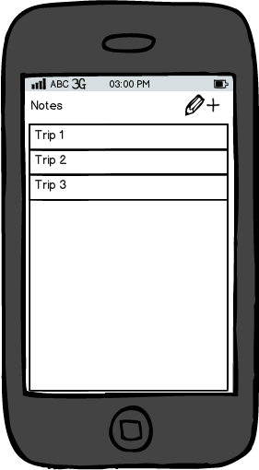

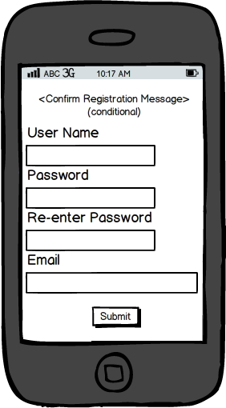

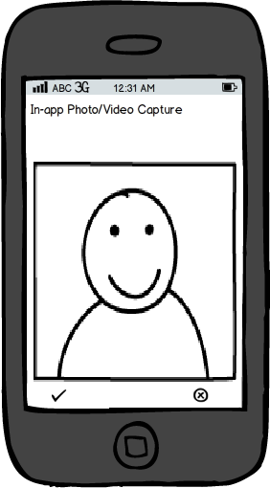

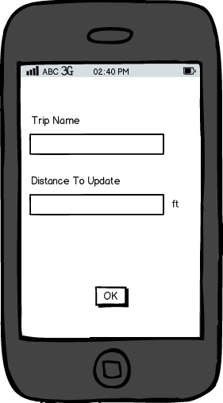

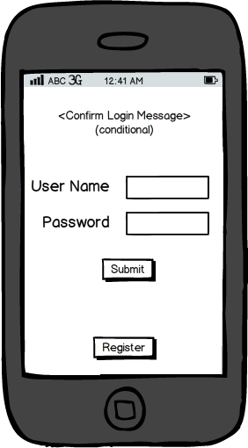

1a

1b.1

2b.3b

2a.1

2a.2

2a.3a

1b.2

2b

2c

2d

2f



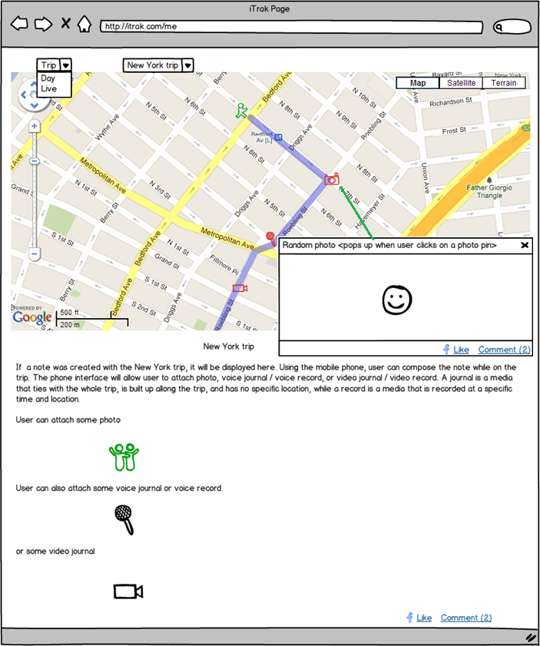

Notify

Notify

2e

Figure 2.5: Mockups storyboard.

|  |  |
| --- | --- |
| Mockup 2.7a | Mockup 2.7b |

Figure 2.7: Main page and live map view mockups.

|  |  |
| --- | --- |
| New trip | Takes to the configuration page for creating a new trip. See Mockup 2.8a in Figure 2.8. |
| Notes | Takes to the notes manager page for creating new notes or editing existing notes. See Mockup 2.8b in Figure 2.8. |
| Voice journal | Takes to the voice journals manager page. See Mockup 2.10a in Figure 2.10. |
| Video journal | Takes to the video journals manager page. See Mockup 2.10b in Figure 2.10. |
| Photo capture | In-app functionality to take picture. See Mockup 2.10b in Figure 2.10. |
| Live map | Takes to the live map view page. See Mockup 2.7b in Figure 2.7. |
| Settings | Takes to the settings page. See Mockup 2.10c in Figure 2.10. |
| Help | Takes to an external web site that has detail information about iTrak. |

Table 2.1: Functionality descriptions of mobile app icons on the main page.

|  |  |
| --- | --- |
| Note entries  Minimum distance to notify new GPS location  Name of the new trip  Mockup 2.8a | Mockup 2.8b |

Figure 2.8: Create trip page and note manager page mockups.

In Figure 2.8, Mockup 2.8a shows how user will create a new trip. User needs to enter the trip name and the minimum distance that triggers a new update for current location. The Distance to Update value helps optimize the performance of the app and the battery life of the smart phone. For example, if the user is travelling on feet, the travel area may be narrow and the distance to update would need to be small to make the map more accurate. If the user is travelling on a car or a train, it can be a long journey that covers a large area and the distance to update can be relaxed to a larger amount to avoid frequent location updates and to save battery life, while still maintaining a reasonably accurate map. More understanding of how the distance to update can impact the performance of a mobile app involving GPS location tracking can be read at [Wae].

Mockup 2.8b shows how the notes manager will be implemented. It consists of a list of created notes and a button to allow creating new notes. User can edit an existing note or start a new one. If a trip is currently active, a newly created note will automatically associate with the trip. If an existing note already associates with the currently active trip, the system will redirect the user to this note when the user attempts to create a new note.

|  |  |  |
| --- | --- | --- |
| Mockup 2.9a | C:\Users\code_warrior\Desktop\mockup.pngMockup 2.9b | Mockup 2.9c |

Sync button to update note

Buttons to attach media to note

Figure 2.9: Note edit mockups.

Figure 2.9 shows the mockups of the note edit page. Mockup 2.9a shows the note edit page in review mode where the content of the note stays in the center and takes most of the space of the page. At the bottom left corner of the page, there are three buttons that allow user to attach a media such as a photo, a voice journal, or a video journal to the note. The next button allows user to synchronize the content of the note to the server. The bottom right corner of the page has the trash bin button that allows the user to delete the note. Mockup 2.9b simply shows the note edit page in edit mode with the QWERTY keyboard.

In Mockup 2.9c, when the user selects one of the media buttons, a list of existing items of the selected media type will pop up and allow the user to attach an item to the note. The added media items will be uploaded to the cloud server if they are not yet available on the server by the time the mobile app updates the note content to the iTrak server (see Chapter 3).

|  |  |  |
| --- | --- | --- |
| Mockup 2.10a | Mockup 2.10b | C:\Users\code_warrior\Desktop\mockup.png    Mockup 2.10c |

Cancel

Accept

Figure 2.10: In-app media utilities and app settings mockups.

Mockups 2.10a and 2.10b show the in-app utilities for recording sound and taking photos or videos. At the bottom of each mockup, there are two buttons that allow user to either accept the captured media or cancel it.

Mockup 2.10c shows the settings page of the iTrak mobile app, where user can configure the app to allow continuous tracking even when no trip is active. User can also select which social network to post activity notifications on when a journal is created or when a trip has started.

As mentioned in the scope of this report, the prototype of iTrak will support only Facebook as the proof of concept. Figure 2.11 shows how the Facebook page of the iTrak user may look like when a new trip is created. In this screenshot, my Facebook test page received a notification from the iTrak prototype with the description “new trip created ok” and the logo image of iTrak. Clicking on the logo will take visitors of the Facebook page to the iTrak website as showed in Figure 2.14, where visitor can further monitor the trip via the map view.

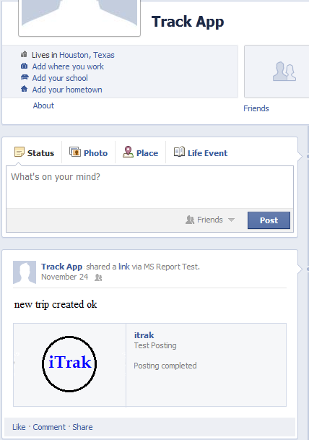

Figure 2.11: Facebook page when received status update from iTrak.

#### 2.4.2 Web App Mockups

The web app consists of a single web page that allows user to share his/her journeys with friends and family. Through this website, people can keep track of the status of the user’s current trip or review the past trips. Figure 2.12 shows the layout of the web app. The top of the website is the control bar which has a collection of the dropdown controls. The dropdown on the left allows a web browser to select the view mode of the page. There are three different view modes:

* Live mode: allows viewers to see status of the user’s current journey in real time (Figure 2.13).
* Trip mode: allows viewers to review the past trips of the user by trip names (Figure 2.12).
* Day mode: allows viewers to review the past trips of the user by date (Figure 2.14).

Below the control bar is the map view, which highlights the itinerary of a trip based on the GPS data collected. It also pins the media taken during the trip. Clicking on a pin will pop up a review window for the associated media. With this map view interface, audiences of the website can conveniently and interactively review the user’s trips and journals.

Below the map view is the note associates with the selected trip. The media that has been added to the note using the mobile app is also shown on the website. For a standalone note, which does not associate with a trip, the control bar and the map view will be hidden. Friends and family of the user access standalone notes via the direct links populated to the social network status updates. At the end of the page is the social network bar that allows viewers to further share a note or a trip of the user on their networks. In Figure 2.12, the Facebook Like and Comment buttons are used as examples for interactions with social network.

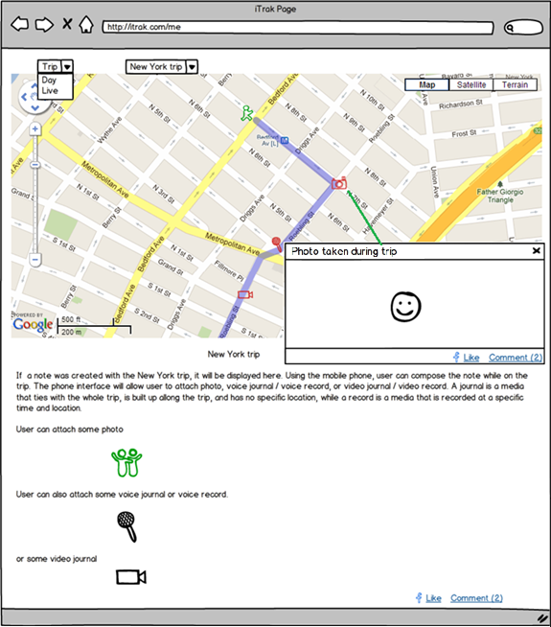

Figure 2.12: Web app in Trip mode.

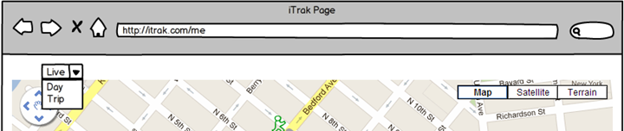

Figure 2.13: Control bar of the web app in Live mode.

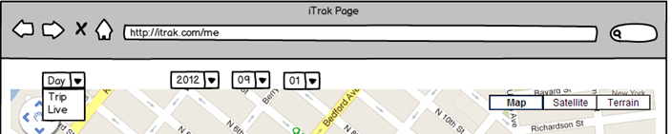

Figure 2.14: Control bar of the web app in Day mode.

## Chapter 3 Implementation

### 3.1 Technology stack

ClosetStylist is an Android app and Java is used as the main programming language. The table below shows a summary of the development environment.

|  |  |
| --- | --- |
| Language | Java, JavaEE, Javascript, KML 2.2 |
| IDE | Eclipse Juno 4.2 |
| Additional code editor | GVIM, Chrome |
| SDKs | JDK 1.6, Android 2.3.3, Facebook 3.0, JSON, Gson 2.0 |
| Test equipment | Samsung S3 |
| System | Ubuntu 12.04 and Ubuntu 12.10. |

Table 3.1: Development environment.

Initially, the development was carried on the main system of my laptop which has an i7-26020M 2.7GHz processor, Windows 7 64bit, and 8Gb of RAM. However, the Android development on the 64-bit Windows platform has showed unstable builds and behaviors which made it difficult to debug the mobile app and severely slowed down the development process. Therefore, I had to configure a development environment on a Windows XP 32bit virtual machine, as showed in Table 3.1, for a more stable platform to develop iTrak. It took longer to build and debug code on the virtual machine. However, it would be more reliable to debug.

In addition to the main development environment, a variety of different technologies have also been considered for using in iTrak. The following sections provide a quick overview of the main technologies being used.

#### 3.1.1 Google Map

The selection for the map view component has been an interesting consideration between Google Earth [Earth] and Google Map [Map] APIs. Both APIs support mapping, drawing markers on a map, or overlaying map using Keyhole Markup Language (KML) [KML]. Google Earth seems to be a stronger candidate with richer features and resources such as 3D view support. Google Earth is also known for its better performance than Google Maps. However, after careful evaluation, Google Maps was decided as the development API for the iTrak’s map view component.

Although Google Earth has better performance and resources, it is a stand-alone application, which requires users to either download the application locally or install a plug-in to use with a web browser. It is not flexible and convenient to deploy iTrak because it requires installation of the external application. In the other hand, Google Maps is an online application and is supported in most browsers. It does not require installation of a separate application or a separate plugin in order to use Google Maps. For the purpose of tracking and marking the media of an iTrak user’s journey, the 2D view in Google Maps is already sufficient to achieve the purpose. Therefore, it would be easier and more convenient to integrate Google Maps with iTrak and deploy it on both the mobile app and the web app.

#### 3.1.2 Facebook APIs

As mentioned earlier, Facebook was selected to implement as the proof of concept for how iTrak would interact with social networks. The Facebook API provides methods for social experience in both web app and mobile app. It is different in how the web app and mobile app can interact with Facebook. Figure 3.1 shows these differences.

On the mobile app side, it requires the iTrak user to log into his/her Facebook account while using iTrak. When the user performs an activity such as creating a new note or starting a new trip, the mobile will use this login information to post a status update to the user’s Facebook page. Then, friends in the user’s network can view the status related to the activity and share it further on their networks. This activity is related to the screenshot in Figure 2.10 above.







Web app

Mobile app

Like or comment

*Facebook pages of the visitors’ friends*

*Friends in the iTrak user’s network*

*iTrak user’s Facebook page*

*Random visitors*

*iTrak user*

Notify

Starts a trip or writes a note

Posts status update

View status update and share the status





#### 

#### 

#### 

Figure 3.1: Interactions with Facebook

While the mobile app posts status updates to the iTrak user’s Facebook page and allows his/her friends to like or comment on the status, the web app allows random visitors of the iTrak website to like or comment on the actual notes posted on the website. Once a visitor like or comment on a note, a notification will be sent to friends in the visitor’s social network and attract more people to the website. This activity is related to the mockup in Figure 2.13.

#### 3.1.3 Cloud Services

Cloud storage is used for storing media data such as photo or video files because of its scalability and inexpensive infrastructure that the providers offer. Amazon Simple Storage Service (Amazon S3) and Google Cloud Storage (GCS) were initially considered. Both of them provide SDKs for Java and offer competitive prices. They also offer similar utilities such as storage manager or backup tools.

Since both iTrak mobile app and web app rely mainly on Google technologies including GAE and Google Map API, GCS seems a better fit for iTrak. It is convenient to setup GCS because it shares the same App Engine Admin Console that is already being used to manage GAE. Communication between a web service hosted on the GAE and the GCS takes minimal effort to achieve thanks to the Cloud Storage API, which is already available in the App Engine SDK. Because of these advantages for sharing the same service provider, Google Cloud Storage was selected to maximize compatibility with other Google technologies.

#### 3.1.4 Java Data Objects (JDO)

Java Data Objects is a standard interface for storing data objects into a database. JDO allows interacting with different kinds of database, including relational database, in an object-oriented approach without using database-specific code. The App Engine Java SDK supports both JDO 2.3 and 3.0 versions. iTrak uses the 3.0 version for the web services.

#### 3.1.5 JavaScript Objects Notation (JSON)

JSON is a lightweight data-interchange format that is based on the JavaScript language [Json]. It is used in iTrak as the alternative to SOAP for data exchange between the mobile client and the web services. More details will be discussed in the Architecture section.

#### 3.1.6 Google Gson (Gson)

Gson is an open-source Java library that allows serialization and deserialization of Java objects to and from JSON format [Gson]. This library essentially reduces the coding effort for using JSON. More details about Gson are available in the Architecture section on Page 25.

#### 3.1.7 VideoJS

VideoJS [Vjs] is an open-source component for web-based video player. It is compatible with both HTML5 and previous version. Using VideoJS not only reduces effort for developing a custom component for the video player but also provides the web app with an intuitive interface for video playback.

#### 3.1.8 Keyhole Markup Language (KML)

KML plays a critical role in the tracking feature. It is a markup language based on XML standard that allows preparing geographic data used with Google Earth or Google Maps applications. KML supports a wide range of interactive activities that can be done with Google Maps, including but not limited to drawing polygons, map overlay, or pinning icons on map. Figure 3.2 shows an example of KML for marking a path made of a single line.

iTrak mainly uses KML for overlaying trip itinerary on Google Maps and for pinning icons for media taken during a trip. KML version 2.2 is currently used for iTrak development.

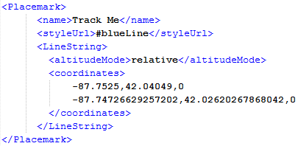

Figure 3.2: KML example

### 3.2 Architecture

Currently, the iTrak development relies on Java and the Android platform for the mobile app. However, the target customers of iTrak are travelers who can be users of any devices or any operating systems available on the market, such as iOS or Windows. Therefore, the architecture for iTrak is required to maximize flexibility and scalability for extending to other platforms in the future. This requirement is also applied to the web service and database designs to assure flexibility for future system migration if needed, such as moving to a different cloud provider for lower cost or for better performance. The design patterns of iTrak also employ the concept of separation of concerns [Cur] [TOHS] to improve the reusability and portability of the code.

Figure 3.3 shows the top-level architecture design of iTrak. The design consists of three main components including the framework, the presentation layer, and the application layer. Each of these components contains modules that are designed to fit in specific business concerns.

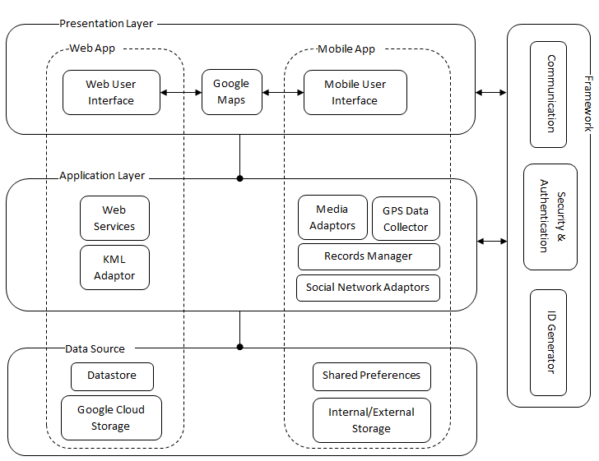

Figure 3.3: iTrak top-level architecture.

#### 3.2.1 Framework

The framework plays the critical role in connecting the presentation layer and the application layer together by implementing the common interfaces and features shared by both layers. There are three major modules in the framework: communication, security and authentication, and ID generator.

##### 3.2.1.1 Communication

In Figure 3.4, the architecture of the communication module is similar to the Platform Supporting Mobile Applications (PLASMA) architecture [Mid] (Figure 3.5).

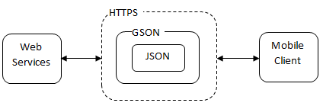

Figure 3.4: iTrak communication module breakdown

One of the main differences between the PLASMA architecture and the iTrak communication module is the use of the standards for presenting data structures. In the PLASMA architecture, Simple Object Access Protocol (SOAP) is used for transferring object data. SOAP is an independent protocol that is supported in most major development platforms, including Java, .Net, and Objective-C. Using SOAP will make the development environment highly extensible to other platforms in the future. However, SOAP is based on XML and therefore will incur overhead during the data transfer. Because of this reason, the iTrak communication module adapts JSON in its architecture for a lighter protocol to transfer object data between the mobile client and the web services, while still achieving the same flexibility and extensibility as SOAP does [Json].

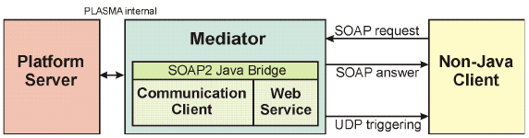

Figure 3.5: PLASMA internal (Source from [Mid]).

In addition to using JSON, iTrak also employs Gson to easily serialize and deserialize Java objects to and from JSON objects. As seen in Figure 3.6, serialization and deserialization can be done in two simple method calls. This feature significantly reduces development effort for handling JSON objects.

Gson gson = new Gson();

gson.toJson(obj); //to serialize

gson.fromJson(json, MyClass.class); //to deserialize

Figure 3.6: Gson example.

##### 3.2.1.2 Security and authentication

Data transferring between the mobile app and the web services occurs over the Hypertext Transfer Protocol Secure (HTTPS) protocol [Https] for secure communication. Establishing an HTTPS connection can be achieved by specifying a trust manager of X.509 standard [Sta429] and set it on the HTTPS connection. Once the HTTPS connection is established, the session authentication for the mobile app can be done by simply requesting a session key via the authentication servlet. This session key will be temporarily saved on the App Engine datastore and stay valid until user logs out of the mobile app or logs into iTrak using a different device.

##### 3.2.1.3 ID Generator

The ID generator is a simple servlet that allows generating random unique identifications for using with different data entities, such as trips, notes, photos, or videos. These unique IDs enable storing and searching for media data on a separate storage, such as the GCS, from the App Engine datastore, which is used to maintain users’ records.

#### 3.2.2 Presentation layer

This layer contains modules that decide the look and feel of the application. As seen in Figure 3.3, the presentation layer covers both web user interface and mobile user interface. Both interfaces share the third party component, Google Maps, for the map view. Since the Google Maps is an online service, integrating the component into the mobile user interface is straight forward by using a Web View control [AWeb] that points to the iTrak web site.

The web user interface is based on Java servlet, HTML, Javascript, and Google Maps API. While the Java servlet and HTML are used to define the data structure and the graphical interface of the website, Javascript and Google Maps API are used to provide intuitive user interactions with the map view and with reviewing the journals.

On the mobile app, the design of the graphical interface follows the Model View Controller (MVC) pattern [KP]. In the MVC pattern, the data model and the view are defined in different domains to separate the concerns between handling the data and presenting the data. Then, interaction between the view and the model can be done via the controller. In the scope of the iTrak mobile app, the view is strictly defined using XML format, while the model stays in the code-behind. Interactions between the view and the model happen via the event handlers.

#### 3.2.3 Application layer

The application layer stays at the heart of iTrak where it implements the components that handle the core functionalities of the application. On the web app, the application layer consists of the components as showed in Table 3.2.

On the mobile app, the application layer implements various components to handle collecting GPS location, managing records, interacting with social network, and recording voice or video journals. These components can be seen in Table 3.3.

|  |  |
| --- | --- |
| KML adaptor | A servlet that allows querying GPS location data and convert it to KML format for using with Google Maps. |
| Web services | A collection of servlets to allow updating records such as user information or journals, or saving/deleting media files. |

Table 3.2: Application layer components on the web app.

|  |  |
| --- | --- |
| Media adaptors | A collection of adaptors that allow creating and editing different types of media, including photo, voice record, and video record. These adaptors rely on the MediaRecorder component available in the Android SDK [Mrec]. |
| GPS data collector | A service that runs in the background to acquire GPS location data. The service is activated when there is an event notification from the Android GPS listener. Upon receiving a new location notification, the collector will upload the data to the iTrak server. If it fails to upload, the data will be saved temporarily for later retries. A life cycle of the GPS data collector can be seen in Figure 3.7. |
| Records manager | A module that holds static record data at run time for user information, trips data, or notes data, etc. |
| Social network adaptors | A collection of adaptors that allow interacting with external social networks. Each adaptor may have different implementation depends on the API the social network provider provides. The prototype for iTrak only experiences with Facebook at the moment. More details about interactions with Facebook are available in Section 3.1.2. |

Table 3.3: Application layer components on the mobile app.



Figure 3.7: GPS data collector life cycle.

#### 3.2.4 Database

ClosetStylist uses SD card to store picture and in the app’s memory to store information related to each item.

iTrak uses different types of data storage for managing data, depends on the nature of the data such as data size or data type. On the server side, App Engine datastore is used to save records that contain small amount of data and can be represented using native data types. Information with non-native data type that can consume a large space of storage, such as photo or video records, is handled by the Google Cloud Storage. This separation of data storage on the server side provides flexibility in migrating or moving database in the future. For example, if other cloud storage solutions appear to be more cost effective and have more efficient performance, the media in the GCS can be migrated to the new cloud without affecting the existing web services, which mainly work with the users records and the GPS data saved on the datastore.

On the mobile app, the Shared Preferences space [Sto] is used to keep track of application settings. Media data that is taken by the user is stored in either internal storage such as built-in memory or external storage such as memory card, depending on which storage is available on the user’s smart phone.

An overview of the data structures used with the above data storages can be seen in Figure 3.8.

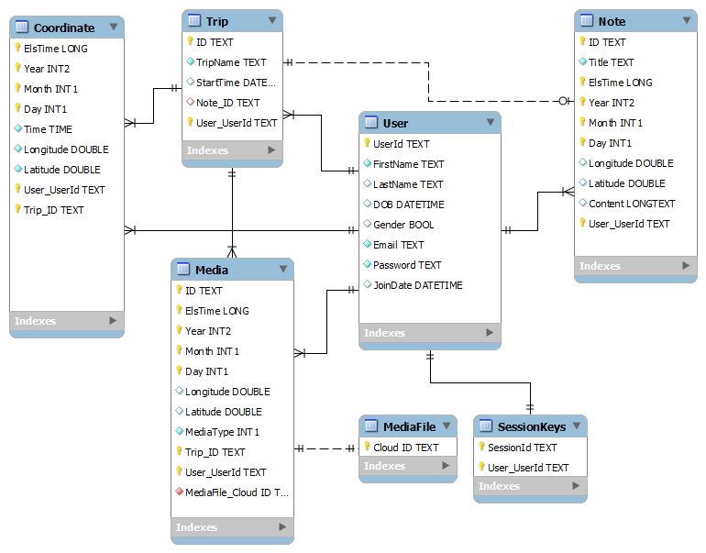

Figure 3.8: Database structures.

### 3.3 Class diagrams

As mentioned in Section 3.2, iTrak employs the concept of separation of concerns. Therefore, separate modules for specific needs were created to maximize flexibility and extensibility. In the mobile class diagram (see Figure 3.9), the Activity classes are responsible for the presentation of the application, the Adapter and Listener classes handle internal data and events, and the Comms class allows communication between the mobile app and the web services.

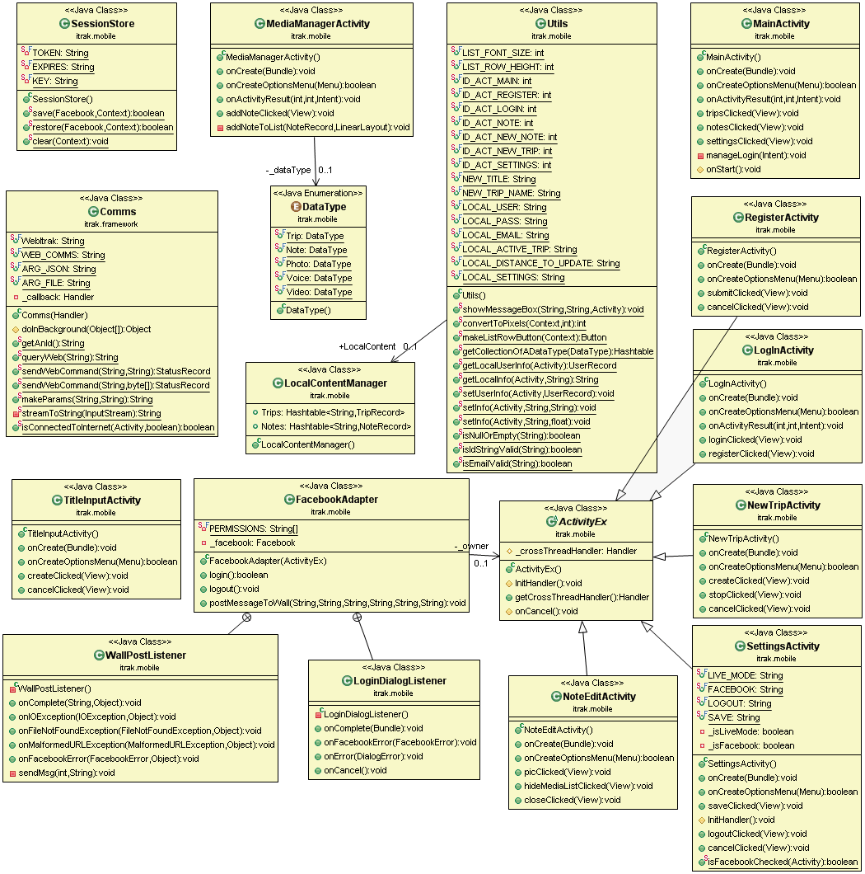

Figure 3.9: Mobile class diagram.

On the other hand, Figure 3.10 shows the web class diagram where the record classes hold persistent data. The IdGenerator class generates unique ID’s for both mobile app and web app. The Comms class filters requests that are sent to the web services and forwards valid requests to the Data Adapter. Finally, the DataAdapter class does the actual processing of these requests.

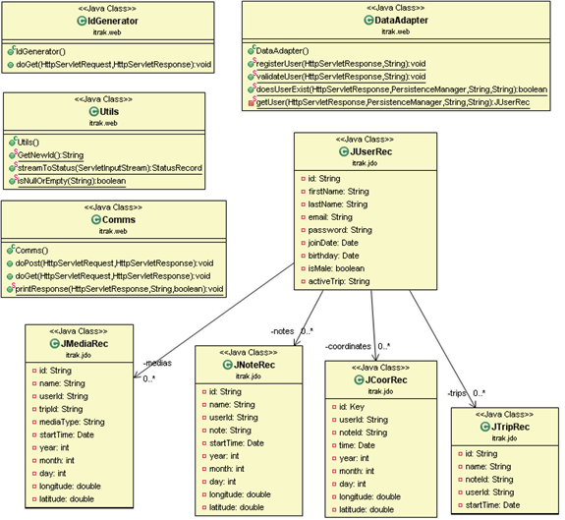

Figure 3.10: Web class diagram.

## Chapter 4 Results

iTrak involves a wide range of technologies and services, from GPS data acquisition to integration with social networks. Therefore, it would be vital to assure that the application delivers accurate data, operates correctly, and has reasonable performance. The following sections describe the main tests conducted for iTrak.

### 4.1 GPS data accuracy

GPS data stays at the heart of the tracking feature. It is important to assure the GPS locations acquired by the smart phone are accurate. There are two methods to measure the accuracy of the acquired data for a route:

* By visually comparing the supposed route with the actual route showed on the iTrak map view.
* By computationally compare the binary data acquired with the supposed data. This method requires preparing a set of data that reflects the expected route. This activity can be achieved by entering a route on Google Maps and then using the GMapToGPX converter [Gcon] to convert the map information to GPX data, which can later be used in the computational comparison.

The GPS data acquisition testing could also be done with different settings of the smartphone. Nowadays, many smartphones are equipped with assisted GPS (AGPS), which is the GPS service using both GPS receiver and the cellular signal to improve the performance for acquiring GPS data [Agps]. However, during a travel trip, user may get to a place where cellular signal is not available. Therefore, iTrak should be tested with both situations when AGPS service is enabled and when it is not.

The iTrak prototype was tested with both visual and computational comparisons using non-assisted GPS receiver on the Nexus S phone.

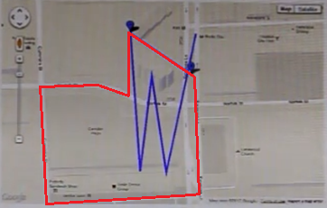

Figure 4.1: Trip overlay tested in Houston area.

Figure 4.1 showed the results of a test conducted by driving a car around a neighborhood in the Houston area at an average speed of 20miles/hr. The blue lines show the trip recorded by the GPS receiver on the Nexus S with the distance-to-update set to 15ft. The red lines show the actual trip. The results show that while the recorded coordinates were somewhat accurate, there was a significant delay on the reception of the coordinates that made the number of received coordinates much fewer than expected, which resulted in an inaccurate overlay of the trip on the Google Map. In this test, the path highlighted in red covers a distance of about 550ft. An approximation of 36 points should be recorded given the 15ft distance-to-update option. However, only 5 coordinates were actually recorded. There were several factors that might affect this delay such as operating in the non-assisted GPS mode, geographical nature of the location, or the quality of the GPS receiver itself. Nevertheless, more testing would be needed to find the exact problem and to improve the tracking feature.

### 4.2 Media upload

iTrak mobile client supports uploading media such as photos or videos attached in a note to the cloud server. Therefore, the upload process should be tested for efficiency and completeness. The media files are uploaded when a note is synchronized by using the Sync button (Figure 2.8). The following situations have been tested using Wi-Fi connections:

* Upload a large media file: individual photo and video files with average size varying between 1MB and 3MB were uploaded to the cloud server. The average upload speed showed good performance at an average of 113KB/s.
* Upload multiple media files together: this test was conducted to test the completeness and fault tolerance of the media uploading feature, based on the following criteria. First, all media files attached in a note must be completely uploaded before the note content is synchronized. Second, if iTrak failed to upload a media file, it should cancel the upload process, save the note content locally, and allow user to synchronize again later. Third, if a media file had already been uploaded earlier, iTrak should not upload the file again. Finally, iTrak should maintain a waiting dialog during the upload process.

For all criteria, iTrak has successfully passed the tests.

### 4.3 Facebook interaction and web app presentation

The interaction of iTrak with Facebook was tested and confirmed working with both the mobile app and web app. Figure 4.2 shows the Facebook status that was updated after a trip was created using the mobile app, while Figure 4.4 shows the web app with the content of the note that associates with this trip. On the web app, a note with some text, a photo, and a video were presented. At the bottom of the web page is the Facebook area where visitors can like the note, send the note to friends, or comment on the note. Although the web app shows the note with rich content of the media, the actual content of the note on the mobile app was minimal as showed in Screenshot 4.3b in Figure 4.3.

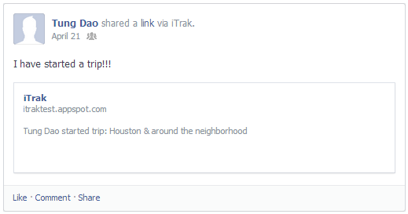

Figure 4.2: Facebook status update screenshot after a trip was created.

|  |  |
| --- | --- |
| Screenshot 4.3a | Screenshot 4.3b |

Figure 4.3: Mobile app screenshots.

Screenshot 4.3a shows the main page of the mobile app with all the buttons that allow performing different tasks as designed in Mockup 2.7a and Table 2.1.

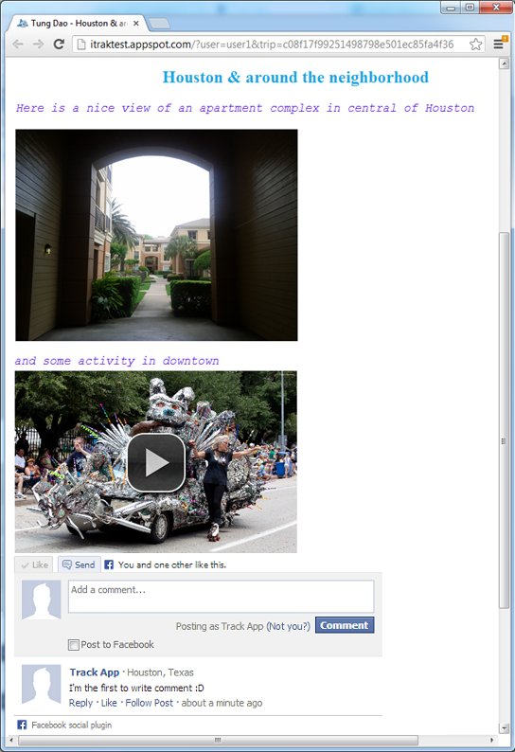

Figure 4.4: Web app screenshot with one Facebook Like and one comment.

### 4.4 Costs and level of effort

The development has been done on free trial services with Assembla [Asbla] and Google. Therefore the development cost was minimal. Table 4.1 shows the cost of equipment and services purchased for the iTrak prototype.

|  |  |
| --- | --- |
| Item | Costs |
| Nexus S phone | $110 |
| MyWi hotspot application  (used to allow hotspot connection from the Nexus S to my iPhone for uploading GPS data during testing) | $25 |

Table 4.1: iTrak prototype development costs.

The iTrak project has consumed a significant amount of time during the past ten months. The hours spent are approximated as follows:

* 40 hours for architecture design.
* 40 hours for GUI design.
* 260 hours for researching, coding, and testing.
* 80 hours for writing the report.

4040 lines of code were written for the mobile client and 1588 lines of code were added for the web services. Figures 4.5 and 4.6 show the code metrics of the mobile client and the web services for further details. These metrics were calculated using the CodePro Analytix plugin [Cpro]. A red item shows an area that exceeds the metric threshold and may need improvement. For example, if average cyclomatic complexity is red, there may be too many nested IF statements or nested FOR loop statements in the code.

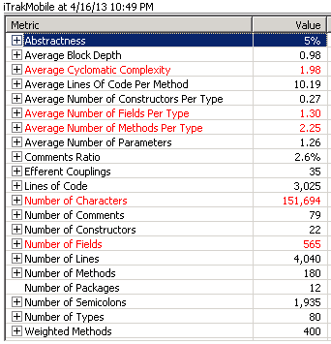

Figure 4.5: Metrics for mobile client.

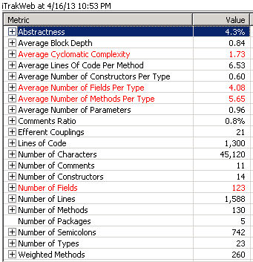

Figure 4.6: Metrics for web services.

### 4.4 Lessons learned

My experience with Eclipse and the Android development as well as the Google App Engine development involved a number of challenges and difficulties that consumed a significant amount of time to resolve. It would be helpful to share some of the lessons learned with developers who would be developing similar apps. The following are my top things to do and not to do.

Do:

* Think about designing a base class for Android Activity that handles multi-threading processes that involve GUI interactions. This will tremendously reduce effort of handling and debugging multi-threading code later.
* Consider code isolation for Javascript used with the web app. This will help avoid conflict with third party Javascript components, which is difficult to identify and debug. Based on the design of the application, an approach for code isolation could be applied. For example, for third party component such as VideoJS [Vjs], the component could be placed in an iframe tag to avoid conflicts with other components. In another example, global variables could be moved to inside an object to avoid conflicts with third party components that might already define global variables with the same names.
* Consider building a separate component that holds static resources and code that can be referenced by both Android project and AppEngine project. This will reduce effort of maintaining similar code in both mobile and web clients.

Don’t:

* Maintain the datastore indexes locally. Let the App Engine handle it automatically when the Persistent Manager interface is called. Editing the datastore indexes locally may make it unstable.
* Mistakenly assume the order of longitude and latitude on the Google Maps website is the same with what should be in the KML format. It depends on where latitude and longitude need to be set. If longitude and latitude are set using Javascript on the web app, the order needs to be latitude-longitude. However, in the KML file, the order must be in the longitude-latitude order. Bugs caused by wrong order of longitude and latitude in the KML file are extremely hard to identify. I spent almost two months to realize that the real-time data update using Google Maps did not work was because of the wrong order of longitude and latitude.

## Chapter 5 Conclusion

### 5.1 Summary

The prototype has been implemented closely to the architecture requirements. Separate modules for specific concerns were created to maximize flexibility and extensibility. The prototype delivered the features as defined in the scope of the report. It also demonstrated the technology and techniques used in the original design. The following captures the key items achieved from the prototype:

* Demonstrated the main workflow to show how the GPS location data and travel journal can associate with each other, and how social network can interact with iTrak to enhance the travel experience.
* Implemented the communication interface using GSON/JSON and proved that this interface significantly reduced effort in handling data exchange between mobile client and web services.
* Experimented with various technologies, including Android, Google App Engine and Google Maps, and showed how they worked together.

Although the prototype has incorporated a variety of technology and integrated a number of exciting features, there is still room to improve. While the UI of the mobile app is well organized, the UI of the web app is still very basic and needs more styling. Existing features such as recording video or recording sound can also be enhanced. More details about related improvements are discussed in Section 5.3.

In conclusion, with a dynamic architecture and a set of features that pick up current trends such as social network and GPS services, the outcomes of this report and the prototype have provided a good foundation for future implementation of iTrak in a full scale.

### 5.2 Related work

As mentioned earlier, one of the advantages of iTrak is to avoid the hassle of maintaining separate applications for different activities a traveler may perform. The following applications are examples that demonstrate the related features supported in iTrak as well as the features in iTrak that these applications do not have.

#### 5.2.1 EverNote

EverNote is an emerging note taking and activity planning application that is available in various systems. The application allows a user to easily take notes of everyday activity. The user can access the notes from different devices such as personal computers, smart phones, or tablets. EverNote will assure the changes made to the notes are synchronized. However, EverNote does not associate with GPS location data and live map view. Therefore, travelers who use EverNote would need to use a separate application for the trip tracking purpose. [Eve].

#### 5.2.2 Video journal devices and apps

Nowadays, travelers often bring a voice recorder or a video recorder, along with the traditional notebook, to record their traveling experience. These recorders can be found on the Internet in the form of portable digital camcorder, such as the Pure Digital PSV-351. User can also use default media recorder applications available on many smart phones to make video or voice journals. However, these devices and applications work independently and require travelers to take extra effort to maintain them.

#### 5.2.3 RunKeeper

RunKeeper is one of the few applications that have tracking ability similar to the iTrak’s vision. The application allows a user to plan a workout activity and then keep track of how much the user has completed the plan based on the GPS tracking data. RunKeeper also allows the user to share the activity with people on the user’s social networks like Facebook. However, RunKeeper does not support note taking or journal recording activities. At the moment, RunKeeper offers RunKeeper Live service which is similar to the live map view in iTrak. However, users would have to pay monthly service fees to use this feature [Run].

### 5.3 Future work

The prototype of iTrak covers only a small set of features as a proof of concept. More work still needs to be done to complete the application as in the iTrak vision. In addition to the main development of iTrak, other features and activities to improve iTrak functionality and usability can be considered. Some of them are discussed in the following sections.

#### 5.3.1 Migration to HTML5

HTML5 is an emerging language for building website. Many web browsers have already supported HTML5. There are major changes in HTML5 to support media elements and scalable vector graphics (SVG). It is considerable to migrate the iTrak web app to HTML5 in the future for enhanced graphical presentation.

#### 5.3.2 Integration with other social network

Currently the iTrak prototype only supports Facebook. It is important to expand the feature to include other social networks such as Tweeter to attract more users.

#### 5.3.3 Customize media recorder

The in-app media functionalities such as recording video or voice journals are based on the Android SDK, which does not support incremental recording. Therefore, iTrak user currently cannot achieve a true voice or video journal. It would be impossible to continue recording a previously saved video or voice journal. Integration with an open-source codec such as JCodec [Jcod] would allow merging multiple media files into a single record and make it a true journal.

#### 5.3.4 Make media players compatible with multiple platforms

Due to the limitation of the Android SDK, iTrak can offer only MP4 as the format for both video and sound records. It would be essential to also support other common formats such as MP3 for sound records and OGG, WEBM, or SWF for video records [W3s]. Similar to customizing the media recorder, this can be achieved by employing an open-source codec in a server client, which will handle converting uploaded media into different formats.

#### 5.3.5 Improve GPS data and map overlay

As showed in Chapter 4, the quality of the GPS data needs to be improved. Implementation of sophisticated filters for GPS data could be considered to address this issue. Algorithms for normalizing GPS data can also be developed to adjust the recorded GPS data and allow the map overlay fit in the actual geographical area.

## Appendix: Balsamiq Mockups

Mockups used in this report were created by using the Balsamiq Mockups software. Balsamiq Mockups is a commercial application that offers a user friendly interface for creating mockups. The interface of the application is intuitive and fast. The application also provides a good set of features to export the mockups into different formats, including XML, PNG, or PDF. Figure A.2 shows the Balsamiq interface with the iTrak mobile app mockups loaded.

The trial version of the software lasts only seven days. After the trial period, user would not be able to save and load the mockups. However, Balsamiq still allows loading a design through the XML importing/exporting interface. Therefore, for academic purpose, a student can continue using Balsamiq after the trial period has expired, by manually saving the design as in the following steps:

1. To save a design, export the design to XML and save the XML onto a file. If changes are made later for the design, export the XML again and overwrite the content of the file with the new XML.
2. To load a design, open the saved XML file and copy the content to the clipboard. Then, paste the XML to the import dialog in Balsamiq. Figure A.1 shows the import interface with the XML content pasted into the import dialog.

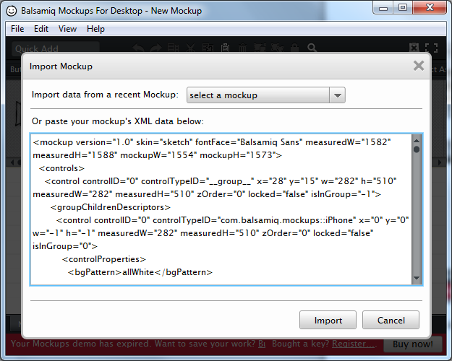

Figure A.1: Balsamiq Mockups XML import interface screenshot.

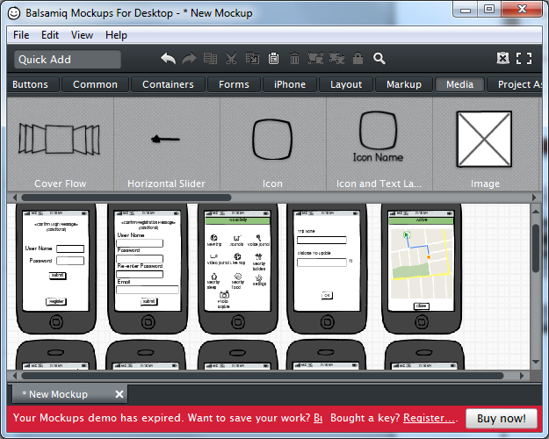

Tools ribbon to build up mockups

iTrak mockups

Figure A.2: Balsamiq Mockups screenshot.

## References

[TLNF2003] Tjøstheim, I.; Lous, J.; Nordlund, B.; Fuglerud, K.S. 2003. Travelers and Location-information in the Mobile Environment – Consumer Attitudes and a Prototype of a Service for Early Adopters of Mobile Internet: *Norsk Regnesentral, Norway*.

[AV] Axup, J.; Viller, S. 2005. Augmenting travel gossip: design for mobile communities: *OZCHI, Proceedings of the 17th Australia conference on Computer-Human Interaction: Citizens Online: Considerations for Today and the Future, pp. 1-4*

[Cur] Curry, E. 2004. Adaptive and Reflective Middleware: *Middleware for Communications: John Wiley & Sons, pp. 43-47.*

[Mid] Langendorfer, P.; Maye, O.; Dyka, Z.; Sorge, R.; Winkler, R. Kraemer, R. 2004. Middleware for Location-based Services: Design and Implementation Issues: *Middleware for Communications: John Wiley & Sons, pp. 306-329.*

[TOHS] Tarr, P.; Ossher, H.; Harrison, W.; Sutton, S.M. 1999. N degrees of separation: multi-dimensional separation of concerns: *ICSE, Proceedings of the 21st international conference on Software engineering, pp. 107-119.*

[Sol] Soley, R. 2000. Model Driven Architecture: *The Object Management Group, White Paper, Nov 27, 2000.*

[Soap] Box, D.; Ehnebuske, D.; Kakivaya, G.; Layman, A.; Mendelsohn, N.; Nielsen, H.F.; Thatte, S.; Winer, D. 2000. Simple Object Access Protocol (SOAP) 1.1: *W3C Note, 08 May 2000.*

[Https] RFC2818. 2000. HTTP Over TLS: *Network Working Group.*

[Sta429] Stallings, W. 2011. Cryptography and Network Security, 5th edition: *Prentice Hall, pp. 429-437.*

[KP] Krashner, G.E.; Pope, S.T. 1988. A Description of the Model-View-Controller User Interface Paradigm in the Smalltalk-80 System: *Journal of Object-Oriented Programming archive, Volume 1 Issue 3, Aug./Sept. 1988, pp. 26-49.*

[Fapi] Facebook SDK for Android. [Online].

<https://developers.facebook.com/android/>

[Json] JSON. [Online].

<http://www.json.org/>

[Gson] Google GSON. [Online].

<http://code.google.com/p/google-gson/>

[Bry] Bryce, T. 2005. Re-Inventing Business Process Design. [Online].   
<http://it.toolbox.com/blogs/irm-blog/reinventing-business-process-design-3238>

[Amb] Ambler, Scott. UML 2 Activity Diagramming Guidelines. [Online].

<http://www.agilemodeling.com/style/activityDiagram.htm>

[Sto] Storage Option. [Online].

<http://developer.android.com/guide/topics/data/data-storage.html>

[Bal] Balsamiq Mockups Software. [Online].

<http://www.balsamiq.com>

[Wae] Waele, D. 2010. Understanding the Location Listener in Android. [Online].

<http://blog.doityourselfandroid.com/2010/12/25/understanding-locationlistener-android/>

[GAE] Google App Engine. [Online].

<https://developers.google.com/appengine/>

[Earth] Google Earth API. [Online].

<https://developers.google.com/earth/>

[Map] Google Maps API. [Online].

<https://developers.google.com/maps/>

[KML] Keyhole Markup Language. [Online].

<https://developers.google.com/kml/documentation/>

[Ecl] Eclipse. [Online].

<http://www.eclipse.org/downloads/>

[AWeb] Android Web View. [Online].

<http://developer.android.com/reference/android/webkit/WebView.html>

[Mrec] Media Recorder. [Online].

<http://developer.android.com/reference/android/media/MediaRecorder.html>

[Vjs] VideoJS

<http://videojs.com/>

[Agps] Android GPS. [Online].

<http://developer.android.com/reference/android/location/package-summary.html>

[Eve] EverNote. [Online].

<http://evernote.com/evernote/>

[Run] RunKeeper. [Online].

<http://runkeeper.com/index>

[Cpro] CodePro Analytix. [Online].

<https://developers.google.com/java-dev-tools/codepro/doc/>

[Gcon] Google Maps to GPX conversion. [Online].

<http://www.elsewhere.org/journal/gmaptogpx/>

[Asbla] Assembla. [Online].

<https://www.assembla.com/>

[Jcod] JCodec. [Online].

<http://jcodec.org/>

[W3s] Video formats. [Online].

<http://www.w3schools.com/html/html_videos.asp>

[Agps] AGPS. [Online].

<http://en.wikipedia.org/wiki/Assisted_GPS>

[Act] Android Activity. [Online].

<http://developer.android.com/reference/android/app/Activity.html>